**A close up of a logo

Description generated with very high confidence**

**FITC 110_Computer Basics and Professional Practice**

**Capstone Final Project**

**Your Technology Future**

Your capstone project in this course will be to create a “map” to your technology future. You will select and research a field/career that you may like to pursue after you have finished the Foundations program.

**Part 1a – File Setup, Notes, Research**

* Open a blank word document, save it as Capstone Map in your FITC 110 Capstone folder
* Use the Capstone Map document to draft your notes and begin to map your technology future
* Be as messy as you like to start your mapping, notes will not be handed in
* Find a technology career that you are interested in or want to pursue. You may not have a career in mind yet, but that is okay. Just find a technology career and work with that for now, e.g. Network Technician. You will then do the research to find the relevant information about this career that is outlined below.

**Part 1b – NOC Research**

* Search the National Occupation Classification (NOC) website for a career: <http://noc.esdc.gc.ca/English/NOC/SearchIndex.aspx>

In this example, a search for “computer” generated 36 titles. From this list, one job title was selected: “Software engineers and Designers”.

The National Occupational Classification (**NOC**) system assigns a four digit **code** and job description for every occupation is the Canadian labour market.

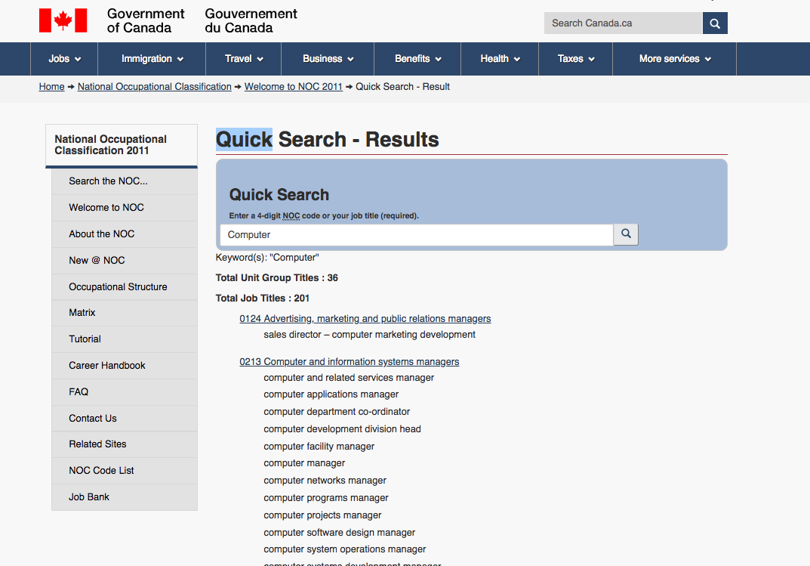

* 1. What is the NOC number?

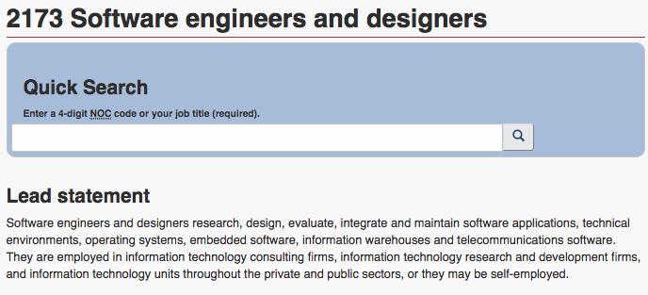

* 1. What are the “Example Titles” and “Employment requirements”

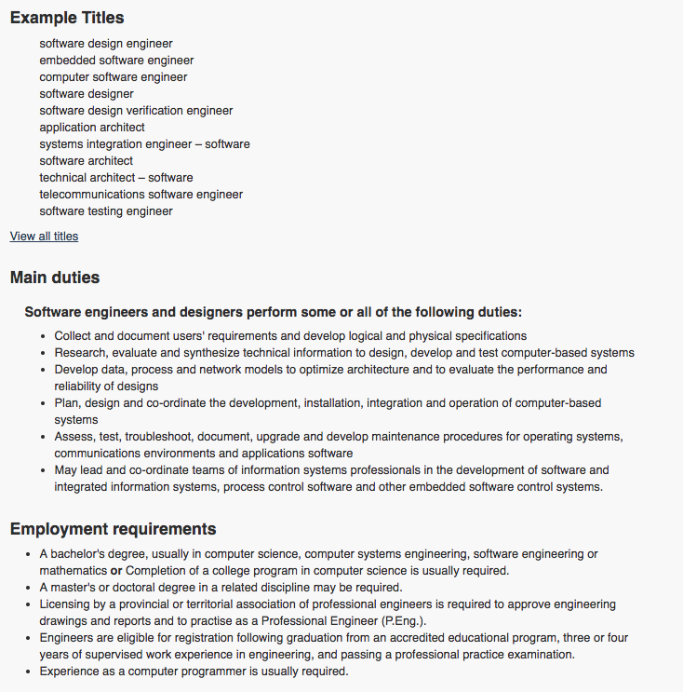

Do an extensive Internet search to seek out tech sector jobs in areas that you are interested in. Try online resources like job apps, company websites, job search sites etc., and try traditional ways of seeking job information like word of mouth, bulletin boards, and newspapers. Most of these traditional avenues will be found online today too.

Search for a job - in the city you are in or would like to be in - that is related your career and education from the first two parts.

* + What is the job?
  + Will your education, when completed, match with the job?
  + How much does the job pay?
  + Are there any other requirements for the position, other than education?
  + Copy the link and paste it into your mapping document.

**Part 1c – Education and Training**

* Find an Institute, College or University that offers advanced training for your future career. Your instructor will be facilitating a presentation on the opportunities in the Futures program, and you will be exploring other opportunities also. You will need to answer the following questions:
* School name and where it is located
* What is the program name?
* Is this a certificate, diploma or degree program?
* Does the school provide the support that you are interested in receiving as a student?
  + Specific programs, individuals, educators, or supports for Indigenous students? What are they? What are the retention rates for Indigenous students? Policies? Example: [Aboriginal Students at UBC](https://you.ubc.ca/aboriginal-students-ubc/)
  + e.g. Aboriginal student advisor, scholarships and bursaries, Indigenous student associations, etc.
* How long is the program (years/months)?
* How many courses do you need to take to complete the program?
* What is the tuition fee? Are there additional fees? What other costs do you need to consider? Feel free to try an Excel spreadsheet (once we have covered it in class).
* What are the pre-requisites/requirements to get into the program?
* When are the intakes for applications and/or registration?
* What about funding: Will your band cover the funding for this course? Will student loans cover the course’s funding? What are your options?

**Part 2**

* Application
  + Prepare a cover letter in MS Word to apply for the position
  + Attach your resume developed in Week 1 Day 5, update to customize for the position

**Part 3**

* Share
  + You will be presenting, in a Power Point presentation, to the class what you learned about the career that you picked. The presentation should include 5-10 slides (roughly) and cover your main research findings about the career, job opportunities, education requirements, and your interest in this career. You can be more formal or more casual, while practicing your public speaking and presentation skills learned in this course. Presentations will be done on the final day of class.

**Part 4**

* File Management & Digital Delivery
  + Have all files saved with professional file names  
    e.g. FITC 110 Capstone – Cover Letter <YI>.docx (YI = your initials)
  + Email or Slack the following documents to your instructor: PPT presentation, cover letter, resume, and mapping document.

The Complete Capstone Project Includes:

1. The **mapping document** in MS Word
2. Your **resume** and **cover letter** applying for the position in MS Word
3. Creating a MS PowerPoint **presentation file** and sharing your research findings by **class presentation** on day 10
4. Sending the files to your instructor on day 10

Be sure to save your document often, check in with your instructor as you draft the capstone, and email or Slack your capstone to your instructor when you have finished.

Due date: Week 2 – Day 5

30% of final grade  
Capstones must be completed with a minimum 15% grade to pass this course.

Keep these files stored in an FITC 110 folder

Remember where you filed them as you will be referring back to them during the program delivery and updating them at the end of the program